**Lecture Note: Numerical Analysis (16) Ordinary Differential Equation**

1. **Problem Statement of Initial Value Problem**

* The 1st order nonlinear ordinary differential equation(ODE)



Solution



1. **Euler’s method: 1st order forward differencing for the 1st function derivative**



* 1st function derivative using the 1st order forward difference formula

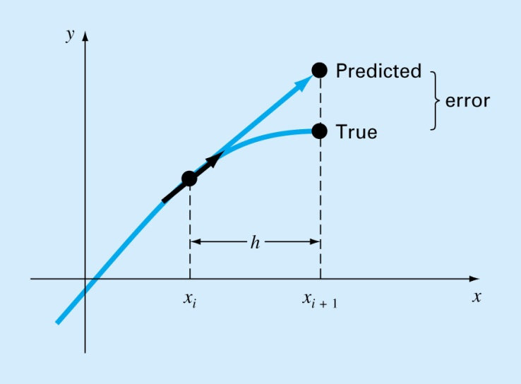



🡪

**See P683 EXAMPLE25.1**

Error in Euler’s Method

* **Error Analysis for Euler’s Method/**

Numerical solutions of ODEs involves two types of error:

* + Truncation error
    - Local truncation error
    - Propagated truncation error
  + The sum of the two is the total or global truncation error
  + Round-off errors

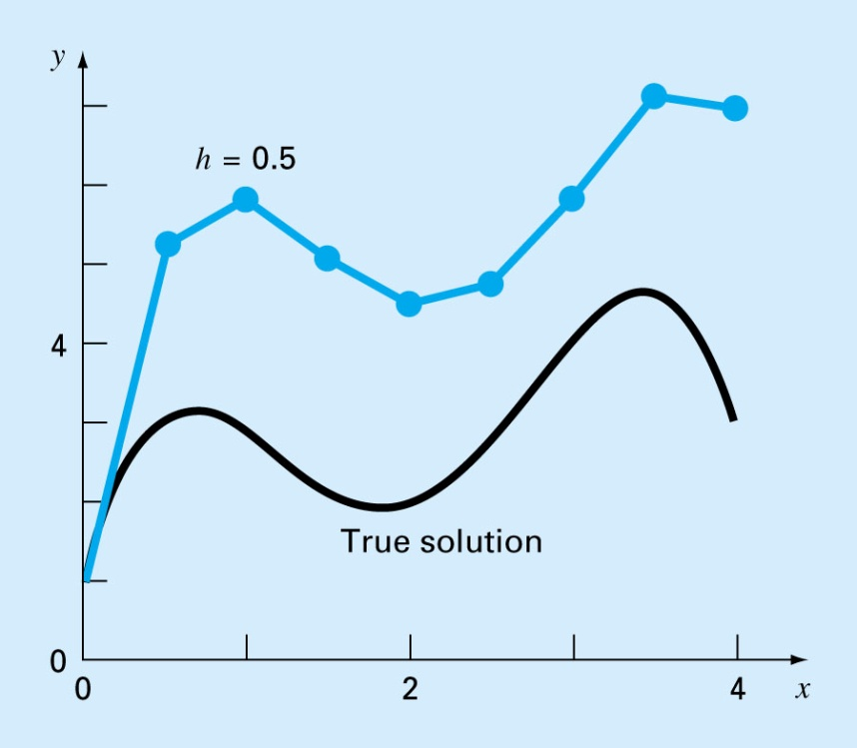

* The Taylor series provides a means of quantifying the error in Euler’s method. However;
  + The Taylor series provides only an estimate of the local truncation error-that is, the error created during a single step of the method.
  + In actual problems, the functions are more complicated than simple polynomials. Consequently, the derivatives needed to evaluate the Taylor series expansion would not always be easy to obtain.
* In conclusion,
  + the error can be reduced by reducing the step size
  + If the solution to the differential equation is linear, the method will provide error free predictions as for a straight line the 2nd derivative would be zero.

1. **Heun’s method: Predictor-Corrector Scheme**



* One method to improve the estimate of the slope involves the determination of two derivatives for the interval:
* At the initial point
* At the end point

**The two derivatives are then averaged to obtain an improved estimate of the slope for the entire interval.**

* Preditor Step: 1st function derivative using the 1st order forward difference formula

 🡪

Prediction of 1st function derivative at using the predicted function value as



* Corrector Step:



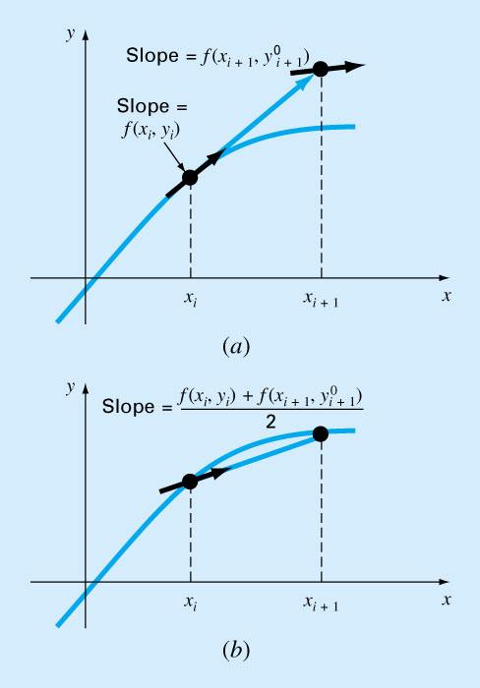

**See P696 EXAMPLE255**

1. **Mid-Point Method**



* Uses Euler’s method t predict a value of *y* at the midpoint of the interval:



1. **Runge-Kutta Method**



* Runge-Kutta methods achieve the accuracy of a Taylor series approach without requiring the calculation of higher derivatives.



* *k*’s are recurrence functions. Because each *k* is a functional evaluation, this recurrence makes RK methods efficient for computer calculations.
* Various types of RK methods can be devised by employing different number of terms in the increment function as specified by *n*.
* First order RK method with *n=1* is in fact Euler’s method.
* Once *n* is chosen, values of *a*’s, *p*’s, and *q*’s are evaluated by setting general equation equal to terms in a Taylor series expansion.

**(5-1) 1st order Runge-Kutta Method**

 🡨 

* 1st order Runge-Kutta Method is the same as Euler’s method

**(5-2) 2nd order Runge-Kutta Method**



The 2nd order approximation 

Using the chain rule,



🡪

Taylor series expansion of 



Taylor series expansion of the 2nd order RK-formula



Comparing two equations

(1) 

(2) 

 **🡪 Four unknowns with three relations, which means the infinite number of RK schem**e

**(5-2-1) Heun’s method with a single corrector (a2=1/2)**

 **🡪** 

**(5-2-2) Midpoint method (a2=1)**

 **🡪** 

**(5-2-3) Ralston’s method (a2=2/3)**

 **🡪** 

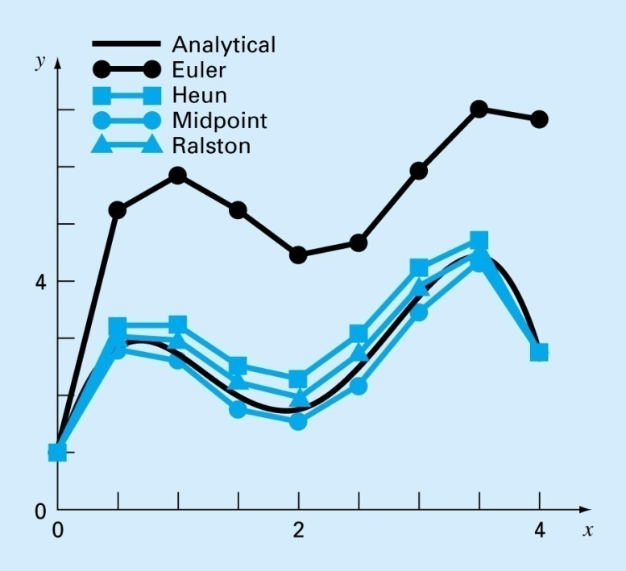

**(5-3) 3rd order Runge-Kutta Method**

**🡪 Eight unknowns with six relations, which again means the infinite number of RK scheme and two parameters should be specified**

**One common version:** 

**(5-4) 4th order Runge-Kutta Method**

**One common version:** 

* Handling higher order nonlinear ordinary differential equation



1. **Systems of the ordinary differential equations**

 which requires n-initial conditions such as 

The equations above can be represented as a vector form as



The we can apply the same formula as in the ordinary differential equation as

(6-1) 1st order Euler’s method 

(6-2) Heun’s preditor-corrector method

Predictor step: 

Corrector step: 

(6-3) Mid point method 

(6-4) 4-th order Runge-Kutta method



1. **Handling higher order nonlinear ordinary differential equation**

(7-1) 2nd order ODE





Then we can transform above 2nd order system into the 1st order nonlinear ODE as

 🡪

(7-2) 3rd order ODE





Then we can transform above 3rd order system into the 1st order nonlinear ODE as

 🡪

1. **Gyroscopic motion of Axisymmetric Body**

**(5-1) The main assumption and definition of axis**

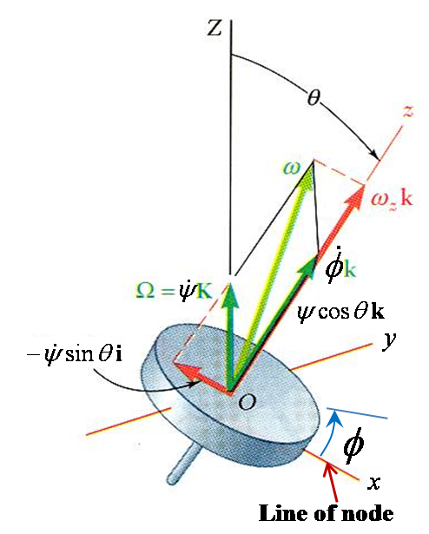

**The Center of mass is fixed in space or the CG of the spinning wheel is located on the center O**

**The spinning wheel is axisymmetric around z-axis and Let**

 

**The angular velocity can be derived using its components in the body-fixed coordinate Oxyz**



**🡪  🡪 **

**: body-fixed rotating coordinate system**

**: not body-fixed rotating coordinate system.**

**The line defined by is called the line of nodes.**

**This axis system is more convenient than to describe the motion**

**The angular rate of Euler angle are given names**



**(5-2) Angular motion equation**

🡪

Or

 





🡪



🡪 

**Using**





**The angular motion equation can be derived as**



**The above equation can be modified as**







🡪 **not easy to solve**

**(5-3) Steady Precession**

**Assumption**

 🡪 

**Angular motion equation**



**Steady Precession is possible only if** are met.

: moment round the line of node

: moment around spinning axis

**Gravitational force generate  moment with CG height **



🡪

**Approximate solution when : High spinning angular velocity**



**Approximate solution for free toque motion: in case CG is the fixed point for Gyroscopic motion**



🡪

**If , the precession angular rate has the same direction as the spinning rate **

**🡪 direct precession**

**Otherwise, the precession angular rate has the opposite direction as the spinning rate **

**🡪 retrograde precession**

**(5-3) Derivation of motion equation for numerical integration using state variables**



* **Case 1) If** 



Let’s define the following state variables



Then, the motion equation becomes



Or







**More convenient form of motion equation for numerical integration in non-dimensional form**

Let’s define a non-dimensional constant  and non-dimensional form of state and control variables using some constant reference of (rate of spin) .



, 



**Then we can rewrite the motion equation as**





* **Case 2) If** 

 🡪 

**(5-4) Numerical Simulation for spinning top**

**(starts from steady rotation and experiences a external disturbance)**

1. **Types of external moments to consider**



Where is a distance between the fixed point and the center of gravity of spinning top



Where non-dimensional parameters are defined as



1. **Defining steady initial condition in case of a steady precession with no rate of precession and no nutation**

**,**   



1. **Equation of motion to be used**

**When , use**









 🡪 

**Otherwise, use**



Where non-dimensional parameters are defined as



1. **Case study**

**Variable Definition Example variable names and these values**

Time span: tspan=[0 100];

Initial condition: y0 =[0.0; 0; 0.0; 0; 0; 1];

Small theta value: epsil = 1.0*10^(-9)

Nondinemsional gravitational torque : tau = 0.1

Nondimensional external torque : torque= 0.0

Ratio of Moment of inertia : bari = 1.0

**Case (I) with the following Data**

tspan=[0 100];

y0 =[0; 0; 0; 0; 0; 1];

epsil = 1.0*10^(-9);% small value

tau = 0.1;%=mgl/I

torque= 0.0;%=T/(Is*omega*omega)

bari = 1.0;%=Is/I

 

**Case (II) with Theta perturbation**

y0 =[0; 0; 0; 0.3; 0; 1];



**Case (III) Negative constant torque**

y0 =[0; 0; 0.0; 0; 0; 1];

torque=-0.1;%=T/(Is*omega*omega)

 

**Case (IV) Theta perturbation + Negative constant torque**

y0 =[0; 0; 0.1; 0; 0; 1];

torque=-0.01;%=T/(Is*omega*omega)

 

**Case (V) Theta perturbation + Negative constant torque**

y0 =[0; 0; 0.1; 0; 0; 1];

torque=-0.012;%=T/(Is*omega*omega)

 

**Case (VI) Effect of Negative constant torque**

y0 =[0; 0; 0.1; 0; 0; 1]; in radian or radian/sec



